Day 3
Exercise - Page 102-103 # 29, 33, 39, 60, 61, 63, 65, 69, 71
29 See back of book
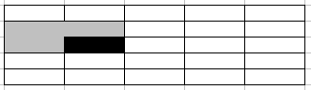
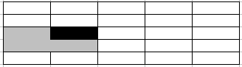
33. A triomino can cover the square to the left of the missing square as shown or in a similar fashion by reversing “up” and “down”. In the case shown, it is impossible to two squares in the top row. In the second case, it is impossible to cover the bottom two squares.

39. See back of book

60. 1 2 3 4 →1 3 4 → 1 3 → 1

61. 1 2 3 4 5 6 → 1 3 4 5 6 → 1 3 5 6 →1 3 5 → 1 5 → 5

63. See back of book

65. J(1000) = 2*(n-2^i)+1 = 977, with n = 1000, i = 9 (2^9 = 512)

69. Let a_{n} = n!. Then Δa_{n} = a_{n+1} - a_{n} = (n + 1)! - n! = n(n!)
Let b_{n} = Δa_{n}. Then b₁ + b2 + … + b_{n} =1(1)! + 2(2!) + … + n(n!)
By exercise 67: b₁ + b2 + … + b_{n} = a_{n+1} - a_{n} = 1(1)! + 2(2!) + … + n(n!)
∴ 1(1)! + 2(2!) + … + n(n!) = (n + 1)! - 1

71. Since p is divisible by k, there exist t such that p = t*k.
Since q is divisible by k, there exist s such that q = s*k.
Now: p + q = t*k + s*k = (t + s) k
∴ p + q is divisible by k.

